**Placement Empowerment Program**



***Cloud Computing and DevOps Centre***

**Back Up and Restore a Cloud Instance: Take asnapshot of your cloud VM. Terminate the VM and**

**restore it from the snapshot.**

Name: Kirubalini S I Department: IT

**Introduction**

In the dynamic world of cloud computing, data loss or system failures can have severe consequences. Implementing a robust backup and restore strategy is crucial for ensuring business continuity and data integrity. Taking snapshots of cloud VMs allows you to capture a point-in-time image of the VM's disk, including the operating system, applications, and data. This snapshot can then be used to restore the VM to its previous state, providing a safety net against accidental deletions, system crashes, or other unforeseen events. The exercise of terminating a VM and restoring it from a snapshot provides a practical demonstration of this critical process.

**Objective**

**Data Protection:** To safeguard critical data and configurations by creating VM snapshots.

**Disaster Recovery:** To enable rapid recovery from system failures or accidental deletions.

**System Rollback:** To provide a mechanism for reverting to a previous working state.

**Testing and Development:** To create consistent environments for testing and development purposes.

**Skill Enhancement:** To gain practical experience in cloud VM backup and restore procedures.

**Verification:** To verify that the snapshot process works correctly, and that a VM can be restored.

**Importance**

**Business Continuity:** Minimizes downtime and data loss, ensuring business operations can resume quickly.

**Data Integrity:** Protects against data corruption or loss due to hardware failures or software errors.

**Compliance:** Meets regulatory requirements for data backup and disaster recovery.

**Operational Resilience:** Enhances the resilience of cloud infrastructure by providing a recovery mechanism.

**Cost Efficiency:** Avoids the costs associated with data loss and prolonged downtime.

**Peace of Mind:** Provides confidence that critical systems can be recovered in case of an emergency.

**Step-by-Step Overview**



Step 1:

1. Go t[o AWS Management Console.](https://aws.amazon.com/console/)

2. Enter your username and password to log in.

Step 2:

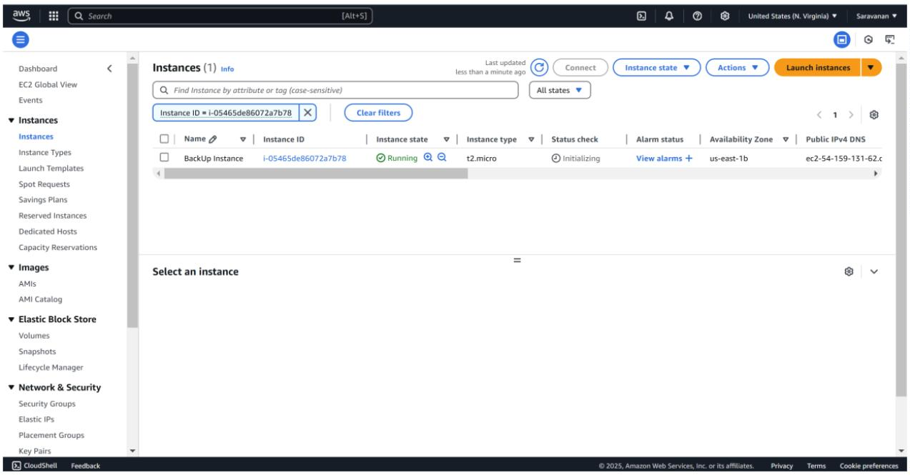

Launch an Ec2 instance.(Backup Instance)

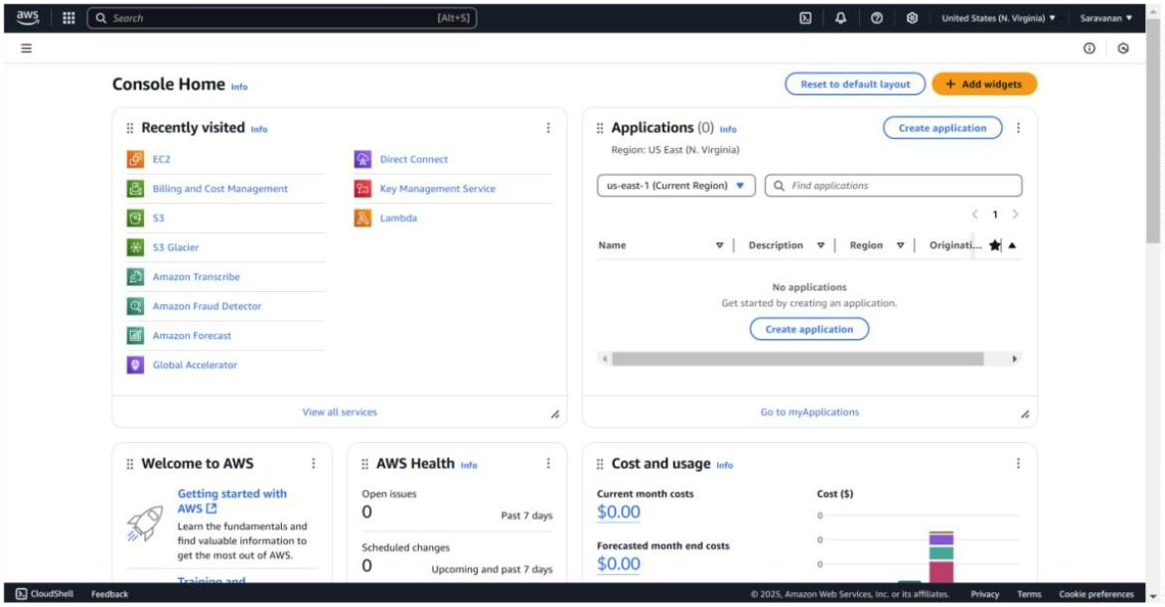

Step 3:

To create a new EBS volume in AWS, go to the EC2 Dashboard in theAWS Management Console by selecting **EC2** from the Servicesmenu. In the left-hand menu, under **Elastic Block Store**, click on**Volumes**, then click the **Create Volume** button. Select **GeneralPurpose SSD (gp3)** for the volume type, set the size (e.g., 8 GiB,within Free Ti er limits), and choose the availability zone that matchesyour EC2 instance (e.g., us-east-1b). Leave the other options asdefault, then click **Create Volume**. Be sure to note the Volume ID forfuture reference.

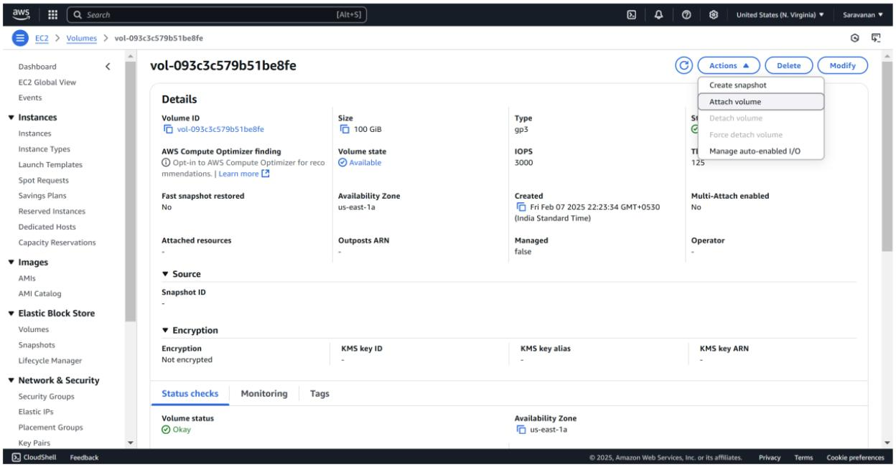

Step 4:

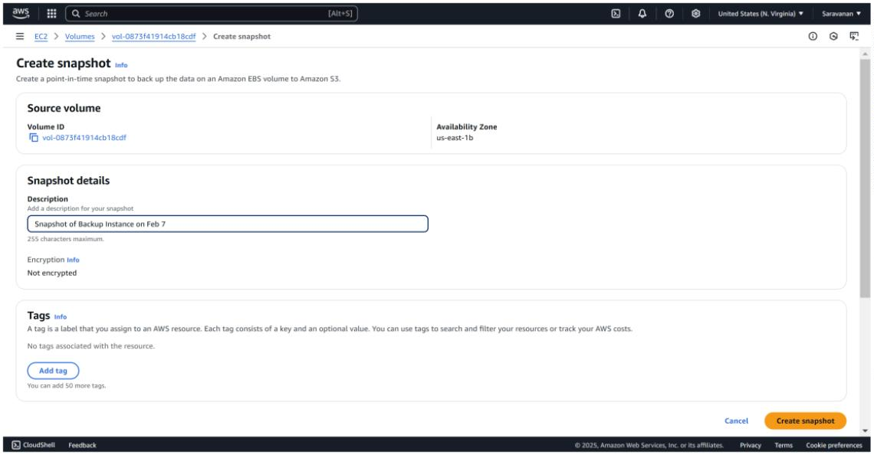

To create a snapshot of your EBS volume, navigate to the EC2Dashboard in the AWS Management Console and click on **Volumes**under the **Elastic Block Store** section. Locate the volume attached toyour instance (it should match the instance name or ID), select it, thenclick **Actions** > **Create Snapshot**. Add a meaningful description (e.g.,"Snapshot of Backup Instance on Feb 7") and click **Create Snapshot**.To monitor its status, go to **Snapshots** under Elastic Block Store inthe left menu and wait for the status to change to **Completed**.

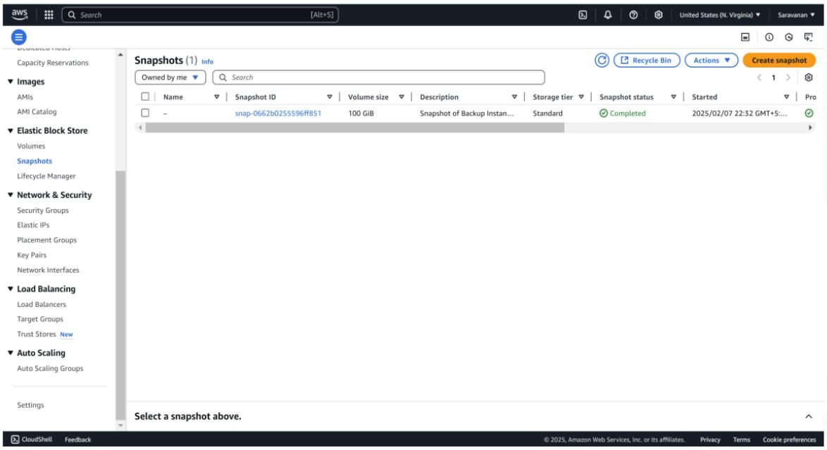

Step 5:

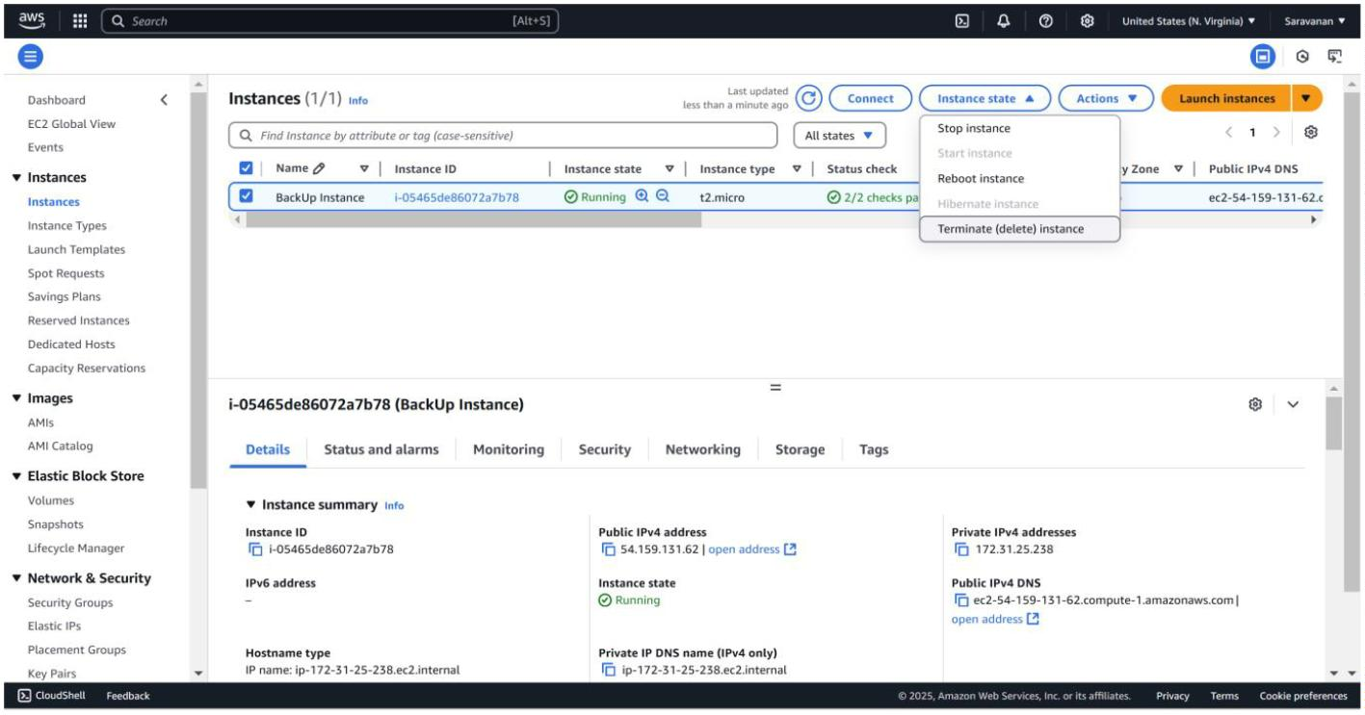

To terminate an EC2 instance, navigate to the EC2 Dashboard in theAWS Management Console and click on **Instances** under the**Instances** section. Locate the instance you want to terminate, thenselect it and click **Actions** > **Instance State** > **Terminate Instance**.Confirm the termination by clicking **Ter minate**, and refresh the pageafter a few moments to see the instance state change to **Terminated**.

Step 6:

To create a new volume from the snapshot, go to the EC2 Dashboardand click on **Snapshots** under the **Elastic Block Store** section in theleft menu. Select the snapshot you created earlier, then click **Actions**at the top and choose **Create Volume**. In the configuration settings,leave the **Size** as is (it will match the snapshot size) and select thesame **Availability Zone** where you want to restore your instance (e.g.,us-east-1a). Fina lly, click **Create Volume** to complete the process

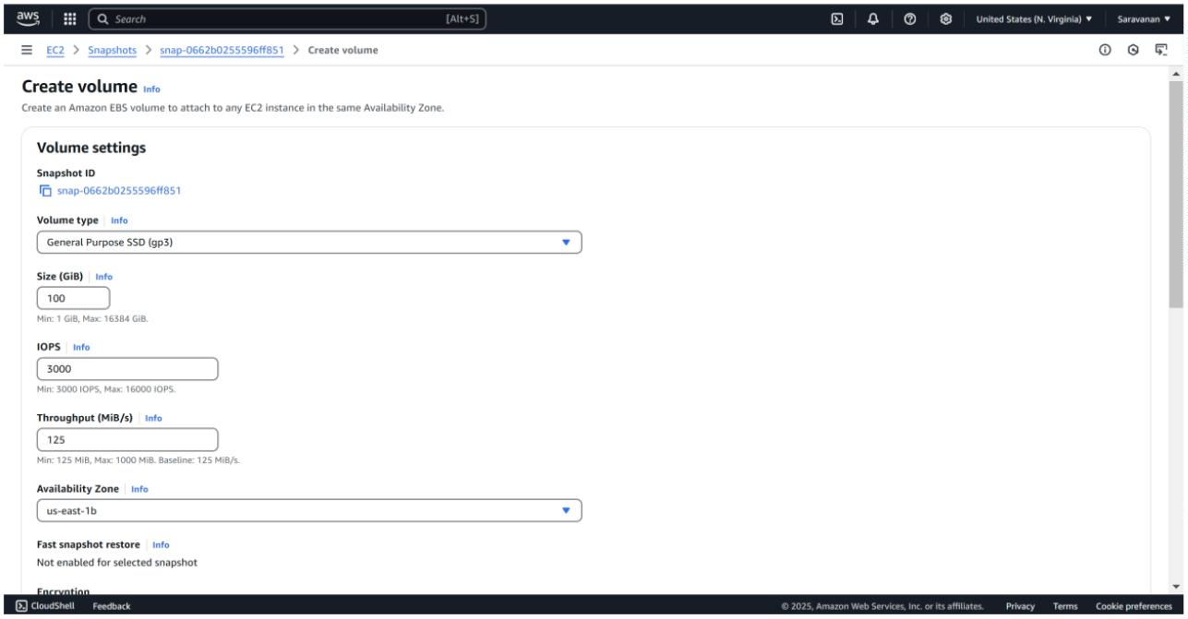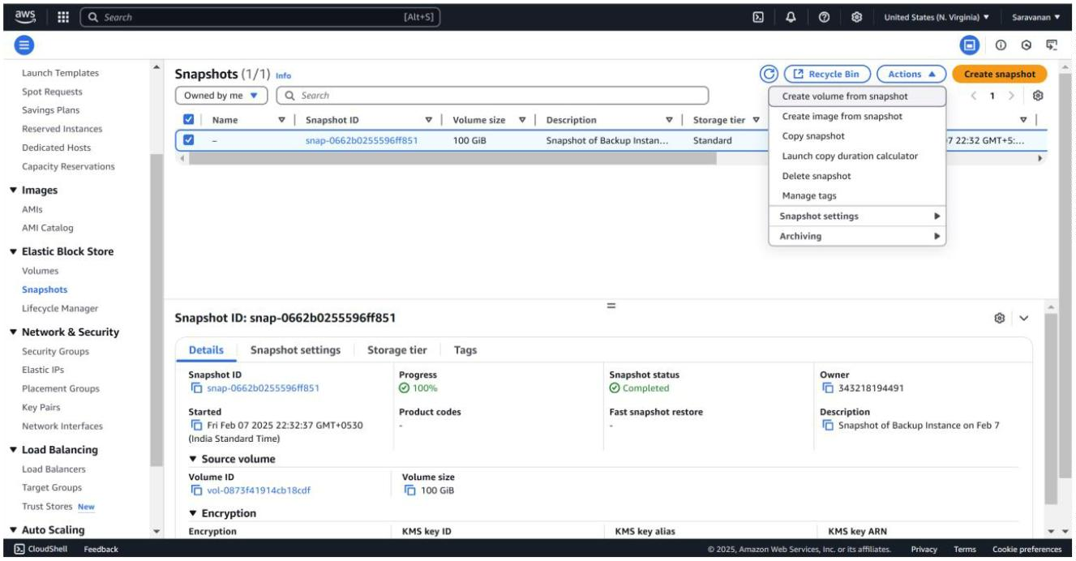

Step 7:

To launch a new instance, go to the EC2 Dashboard and click **LaunchInstances**. Set the na me of the new instance (e.g., **Restored-POC-VM**) and choose the same AMI (e.g., **Amazon Linux 2023 Free Tiereligible**) as the original instance. Select **t2.micro** for the instance type(Free Tier eligible). Configure the instance as needed, but skip thestorage section for now.

Step 8:

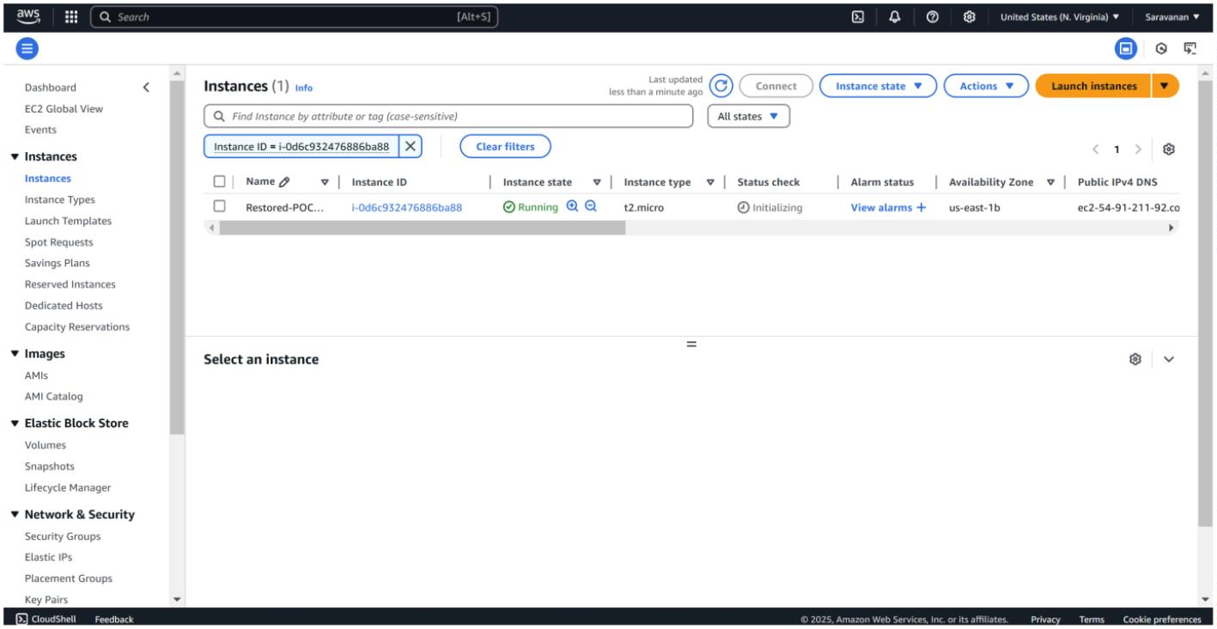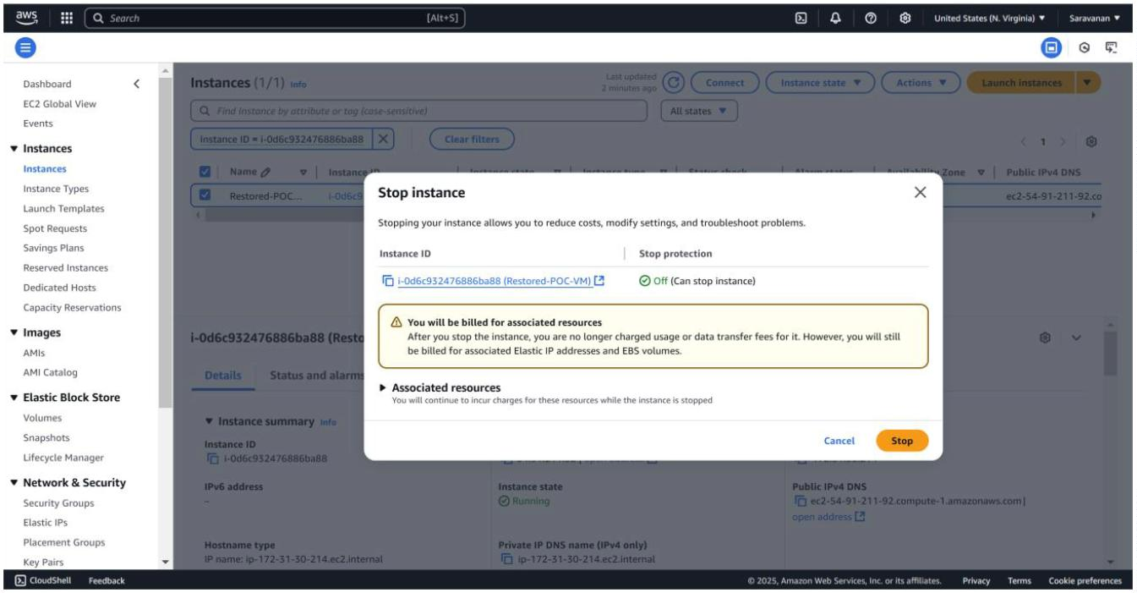

To attach the volume to the instance, first, stop the instancetemporarily after it is launched by selecting the new instance, thenclick **Actions** > **Instance State** > **Stop Instance**. Next, go to**Volumes** in the left menu and select the new volume created from thesnapshot. Click **Actions** > **Attach Volume**, and in the pop-upwindow, choose the new instance to attach the volume.

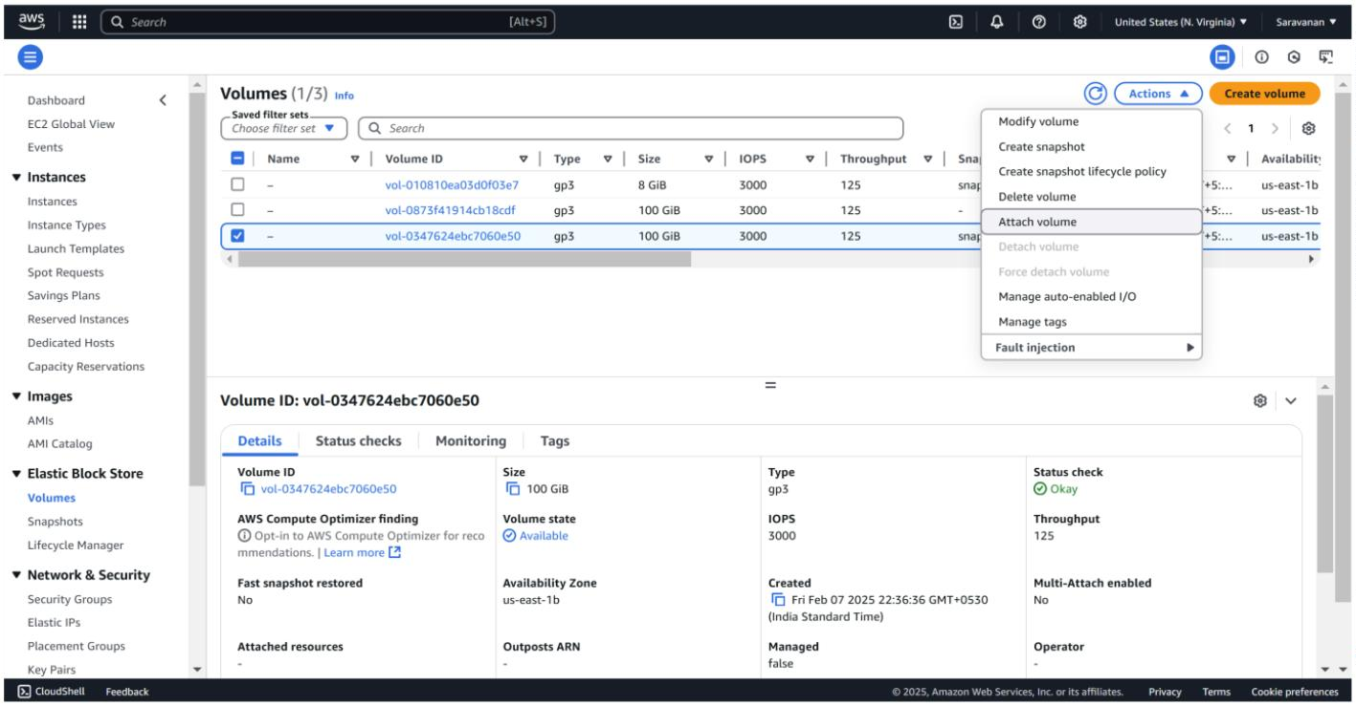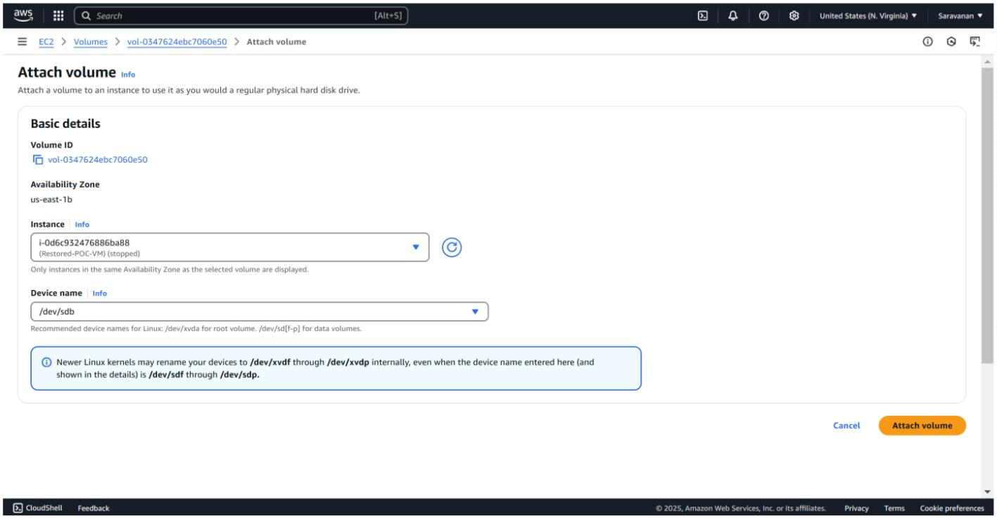

**Outcome**

**Successful VM Snapshot:** Creation of a reliable snapshot of the cloud VM's disk.

**Demonstrated Restoration Process:** Successful restoration of the VM from the snapshot.

**Reduced Downtime:** Quick recovery of the VM, minimizing service disruption.

**Data Preservation:** Preservation of data and configurations from the point-in-time snapshot.

**Improved Recovery Skills:** Increased proficiency in cloud VM backup and restore procedures.

**Verified Backup Strategy:** Validated the effectiveness of the snapshot and restore process.

**Increased confidence:** Confidence in the ability to recover from issues.